Cloudlab Brief Manual

# Hardware:

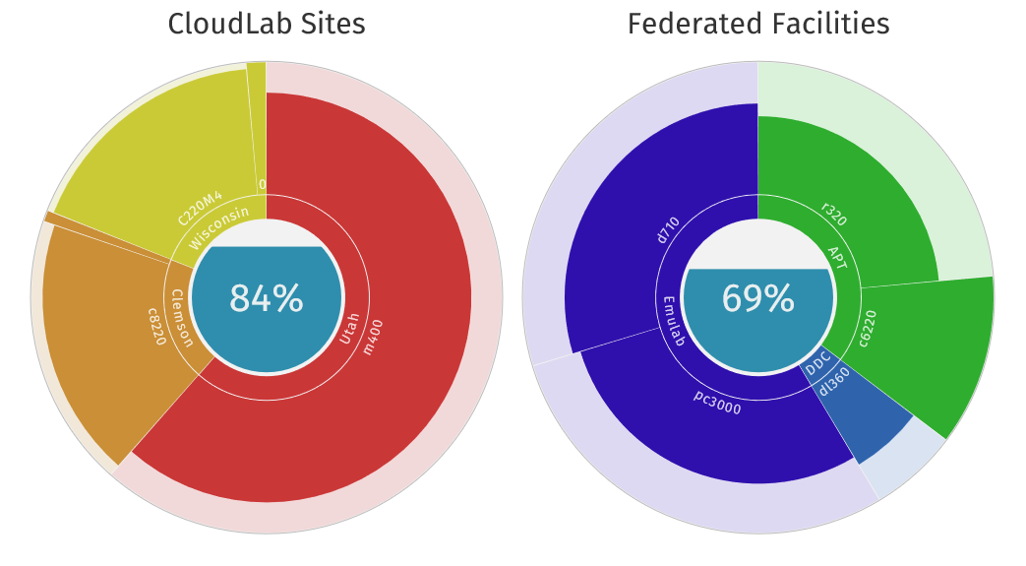

There are a lot of different sites for cloudlab, some are owned by it, some are only federated by it.

* For cloudlab sites, the nodes are quiet powerful (i.e. 2x8 cores, 128GB memory). But these sites usually have very limited available nodes. The only exception is Utah site. But nodes there are based on ARM architecture which may bring you a lot of trouble during development. **If you are looking for small cluster with monster capability nodes, then nodes at Wisconsin site and Clemson site are your choice**.
* For federated sites, the nodes are less powerful (i.e. 4-8 cores, 12-16GB memory, exceptions include c6220 which are as powerful as nodes in cloudlab site). **If you want large cluster with entry level performance nodes, then r320 from APT site should be a good choice.**

# USAGE

I’ll introduce some very basic usage of cloudlab, remember that I have just played with it for a few days, so there might be errors here and there in this note. For a more complete manual, visit: http://docs.cloudlab.us/

## Prerequisite:

1. Add an SSH key to your account  
   Actions -> Manage SSH Keys  
   For the add key, there is a public key blank need you to fill in. To generate the key, we use puttygen. You can download it from http://www.chiark.greenend.org.uk/~sgtatham/putty/download.html
2. Use puttygen to generate an private key, change the key comment to your account id and save the private key.   
   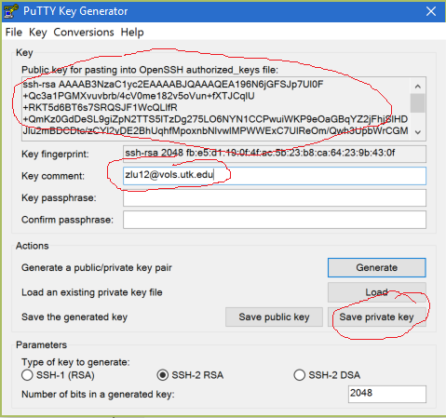
3. Copy the public key to fill in the public key blank in step 1 and click add key  
   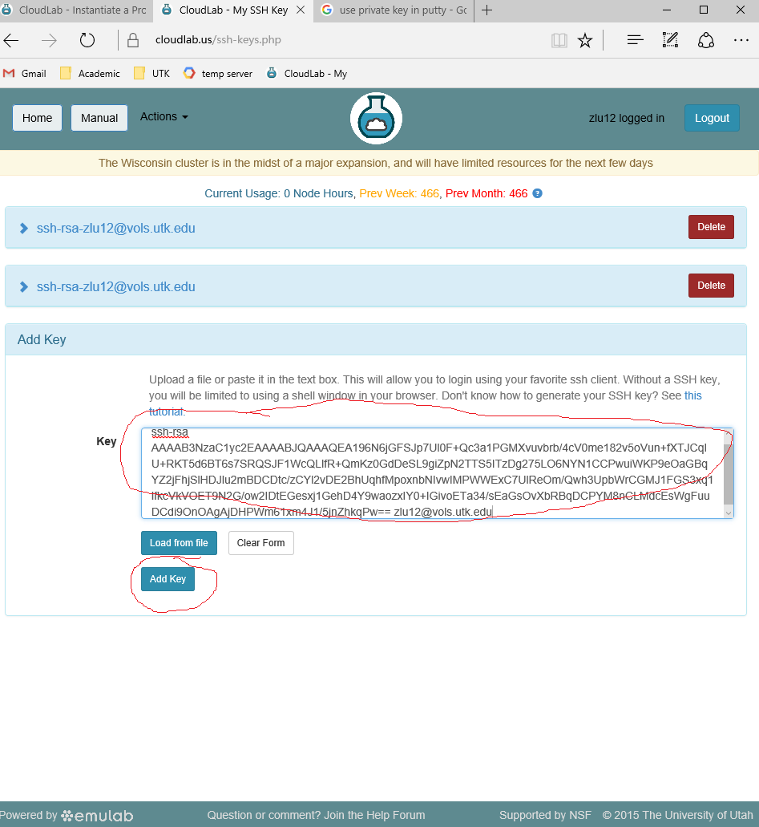

1. In the future when you need to access nodes in your experiments, use the private key you generated (for putty, specify your key file in SSH->AUTH as shown in following figure). This key will be automatically valid for all your future experiments, you don’t have to regenerate it for each experiment.  
   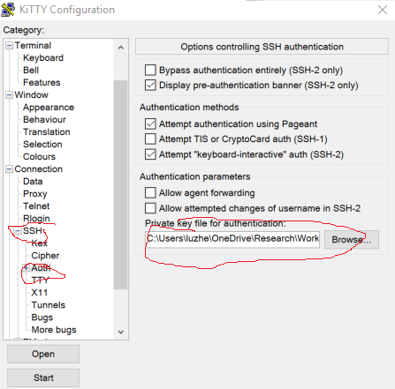

## Create a profile and start an experiment (cluster):

1. In cloudlab, the first thing is to configure the cluster you want. To do this, you need create a profile first and start an experiment based on that profile (just like classes and objects in OO).
2. There are two ways to create a profile:
   1. Simple way: copy from an already available profile.  
      Actions -> Start experiment -> Change profile -> Pick a profile that is closest to your needs-> Copy profile-> Modify the profile as you want (refer to step 3) -> Create
   2. Advanced way: build your own from scratch.  
      Actions -> Create profile -> Configure the profile as you want (refer to step 3) -> Create
3. Configure / modify the profile  
   There are several ways to do this:
   1. ‘Topology’ can give you a more intuitive and clear view of the structure of cluster.
   2. ‘Source’ is a more general way to do this.

I will introduce the ‘topology’ way in the following, for the’ source’ way, you can read source from other available profile and learn how to use it.

* 1. Thing to configure in ‘topology’:  
     click topology to start topology editor  
     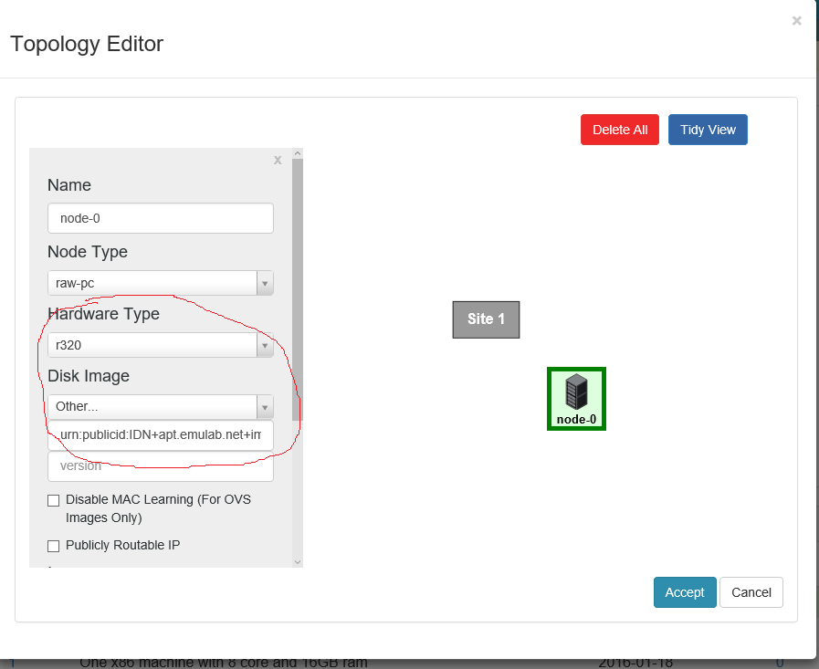
     1. To specify the site you want to build the cluster, click the node and choose the according **hardware type** (i.e. r320 for APT site).
     2. To specify the image, click the node and choose the according **disk image** (i.e. Ubuntu 14.04). You can also **use your own image** here by choosing ‘other’ and specify the urn, this is very useful for continuing research.

1. Start your experiment  
   Actions -> Start experiment -> Change profile to the one you want to use -> Parameterize (optional) -> Finalize (here you can choose site, but are limited to the hardware type you specified in your profile) -> Finish.  
   The experiments usually take some time to boot, especially when you use your own image, when the status shows ready.
2. Connect to nodes  
   Click List view and the command provided to connect to nodes will be shown  
   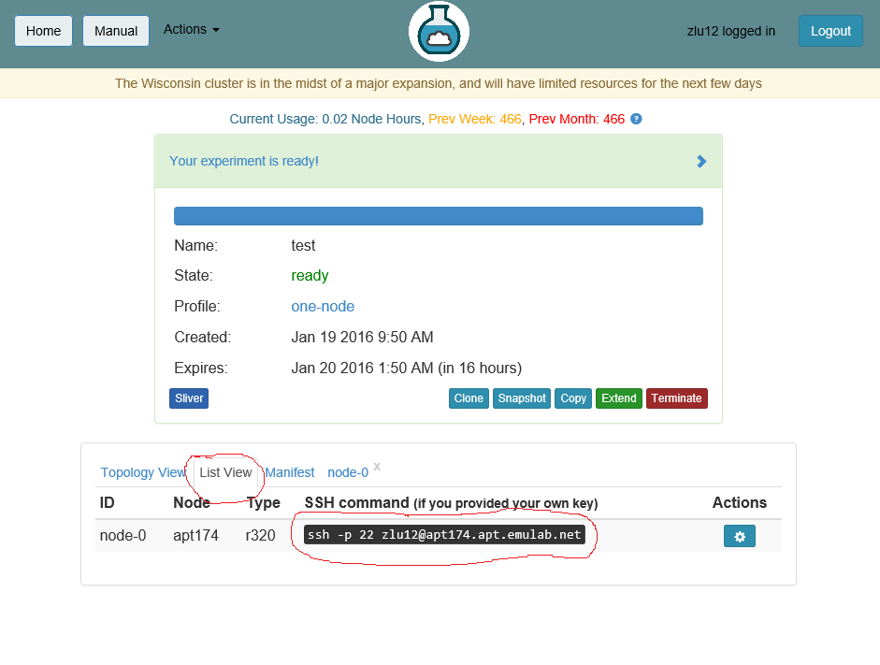

## Create and use your own image:

Experiments/Clusters on cloudlab are only available for a short period of time, even though you can extend it you need to terminate it eventually. When you terminate your experiments, **all your work on the hard disk will be swiped**. To avoid set up develop environment every time you build a cluster, you can create an image and use it in future experiments to continue your work.

1. Select the experiment from which you want to create an image  
   Action -> My experiments -> select the experiment you want
2. Create an image  
   **Note: Files in your home directory will not be saved. It is highly recommended that you put all your files in /local directory**  
   clone/snapshot (read the description for their difference) -> create  
   This may take a few minutes depend on the size of the image. Upon success, there will be a screen shown the urn of the image. **Save the urn for later use**.  
   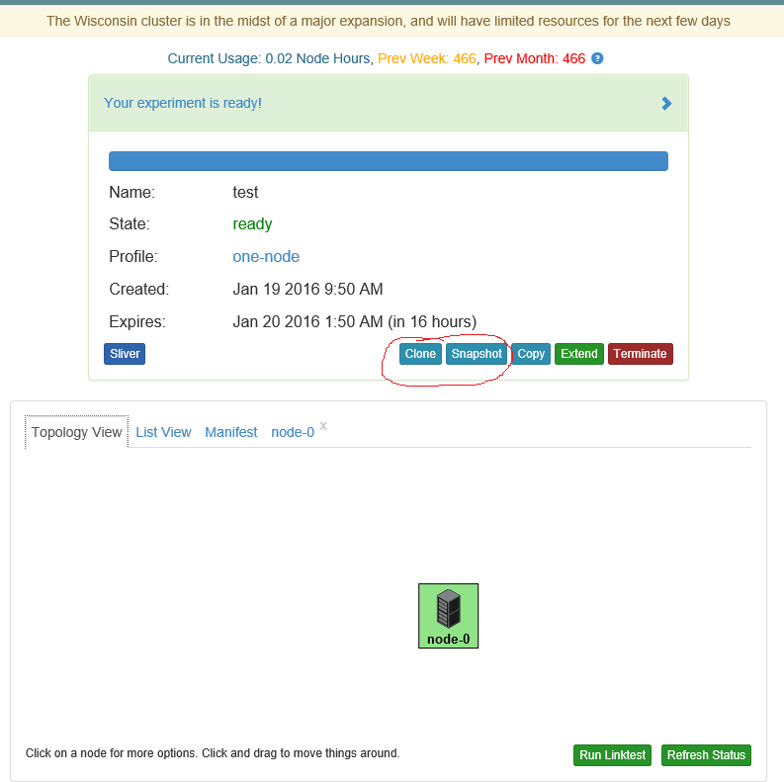
3. Use the image  
   When create/edit your profile, in topology view, click the node and choose other for disk image. Fill in the blank below with the urn provided in step 2  
   

## Add storage/dataset:

Since the default disk space is only around 15-20GB per node, you may find it too small for some purpose.

1. Add a storage:

When create/edit your profile, in **source view**, add the following line in the code:  
<emulab:blockstore class="local" size="100GB" name="datasets" mountpoint="/mydata" />

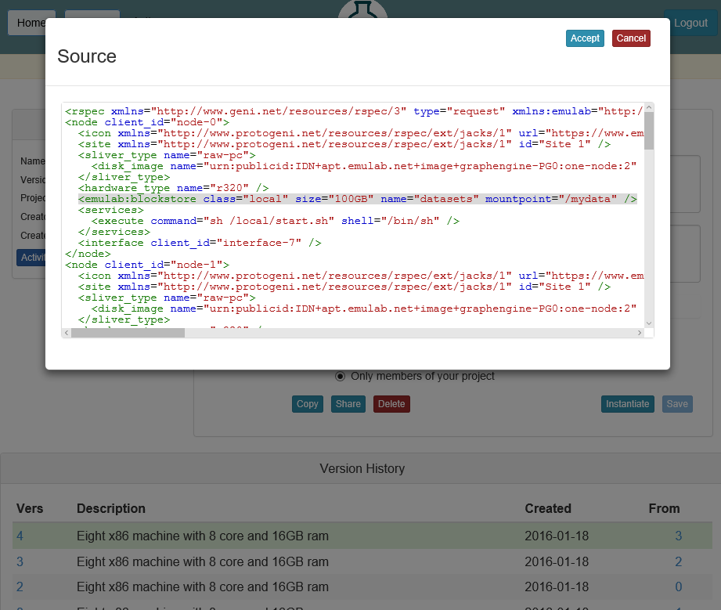

1. Add a dataset  
   I haven’t successfully added any kind of dataset. I will update this once I succeeded.